Report: Refactoring Payment System with Strategy Pattern The original
Report: Refactoring Payment System with Strategy Pattern The initial PaymentProcessor implementation exhibits several design deficiencies. Primarily, it contravenes the Open/Closed Principle (OCP); specifically, the addition of a novel payment method necessitates modifications to the process_payment method, thereby potentially introducing errors. Furthermore, the class demonstrates a high degree of coupling to all payment types, which complicates maintenance. Finally, the extensive if-elif chain diminishes both readability and scalability as the number of payment methods expands. The Strategy Pattern addresses these shortcomings by encapsulating each payment algorithm within its own dedicated class. Rather than embedding logic directly within PaymentProcessor, the processor delegates payment processing to interchangeable strategy objects. This approach separates the PaymentProcessor's context from its specific implementations, thereby enhancing both flexibility and ease of maintenance. As articulated by Gamma et al. (1994), the Strategy Pattern establishes a collection of algorithms, encapsulates each one, and facilitates their interchangeability, thereby enabling the algorithm to evolve independently of the clients that utilise it. In the revised implementation, a PaymentStrategy interface establishes the contract for all payment methods. Concrete strategies, including CreditCardStrategy and PayPalStrategy, implement the pay() method, incorporating their unique logic. The PaymentProcessor class maintains a reference to a strategy and delegates payment requests to it. Strategies can be dynamically exchanged at runtime via set_strategy(), thus enabling dynamic behaviour without necessitating modifications to existing code. This design presents several advantages:
Extensibility is key; new payment options, like bank transfers or cryptocurrency, can be integrated simply by adding new strategy classes, leaving the PaymentProcessor untouched. Maintainability improves, too, since each payment method operates independently, simplifying both debugging and updates. Flexibility is built-in, allowing the processor to switch strategies on the fly, accommodating a wide range of payment scenarios. Readability benefits as well, with the elimination of convoluted conditional logic, resulting in cleaner, more comprehensible code. The refactored code achieves these goals by correctly implementing the Strategy Pattern. It showcases a clear separation of concerns, complies with the Open/Closed Principle, and provides a scalable base for future payment methods.
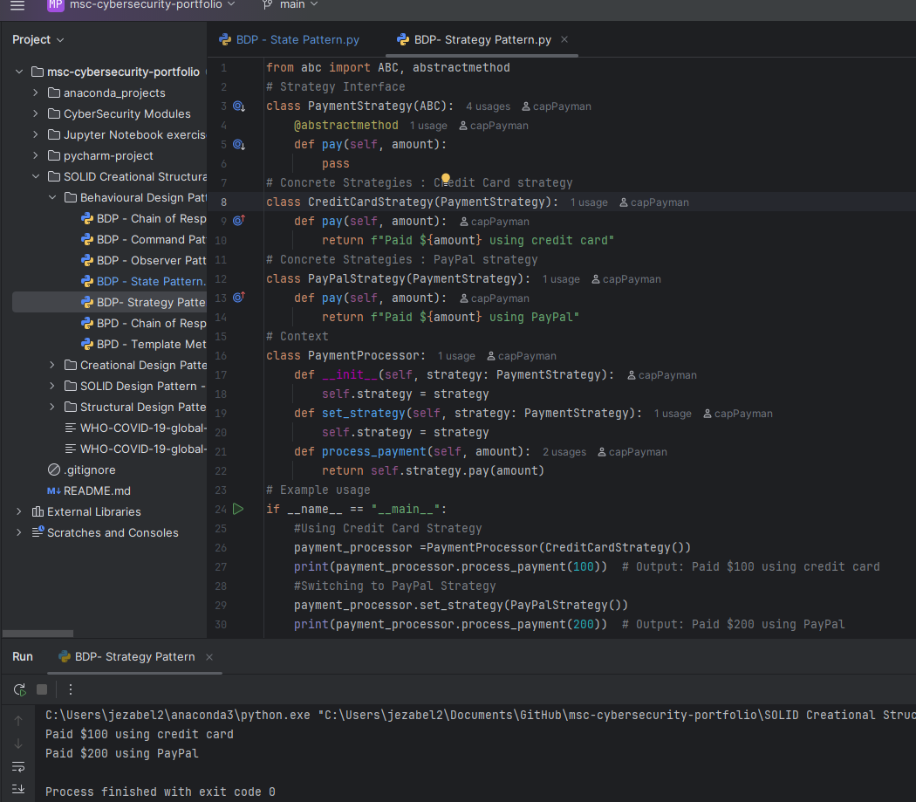

Reference

- Gamma, E., Helm, R., Johnson, R., & Vlissides, J. (1994). Design Patterns: Elements of Reusable Object-Oriented Software. Addison-Wesley.
- Freeman, E., Robson, E., Bates, B., & Sierra, K. (2004). Head First Design Patterns. O’Reilly Media.
- Martin, R. C. (2003). Agile Software Development: Principles, Patterns, and Practices. Prentice Hall.

